From Data to Insight: A Comprehensive Data Science Exploration Report

Introduction

Based on the provided dataset, here is a general introduction:  
  
The dataset provides information on 29 patients' blood glucose levels (BG) and continuous glucose monitors (CGM) readings over a period of 8 hours, from 6:00 AM to 8:00 PM, on October 25, 2023. The patients' ages range from adolescents to adults, and their risk levels vary from low to high. The dataset also includes the patients' HbA1c (HBGI) levels, which indicate their average blood sugar control over the past 2-3 months.  
  
From the dataset, we can observe that the patients' blood glucose levels fluctuate throughout the day, with some patients experiencing higher levels in the morning and afternoon, while others experience lower levels. The CGM readings provide a more detailed picture of the patients' blood sugar levels, showing the magnitude and duration of high and low blood sugar events.  
  
The dataset also highlights the importance of individualized treatment plans, as the patients' ages, risk levels, and HbA1c levels vary significantly. Healthcare providers can use this information to tailor their treatment plans to each patient's unique needs, ensuring that they are able to effectively manage their blood sugar levels and prevent complications.  
  
Overall, the dataset provides valuable

Summary Statistics

Based on the provided dataset, here are some key statistics and insights: 1.  
Count: The dataset  
contains 31680 observations.  
2.  
Mean: The mean value of BG, CGM, CHO, and insulin is 113.15, 116.4,  
0.13, and 0.03, respectively.  
3.  
Standard deviation: The standard deviation of BG, CGM, CHO, and  
insulin is 52.7, 52.6, 1.3, and 0.15, respectively.  
4.  
Minimum: The minimum value of BG, CGM, CHO,  
and insulin is 6.6, 39, 0, and 0.0065, respectively.  
5.  
25th percentile: The 25th percentile of BG,  
CGM, CHO, and insulin is 77.5, 79.4, 0, and 0.0101, respectively.  
6.  
50th percentile: The 50th  
percentile of BG, CGM, CHO, and insulin is 104.5, 107.0, 0, and 0.0146, respectively

Most Correlated Feature Graph Analysis

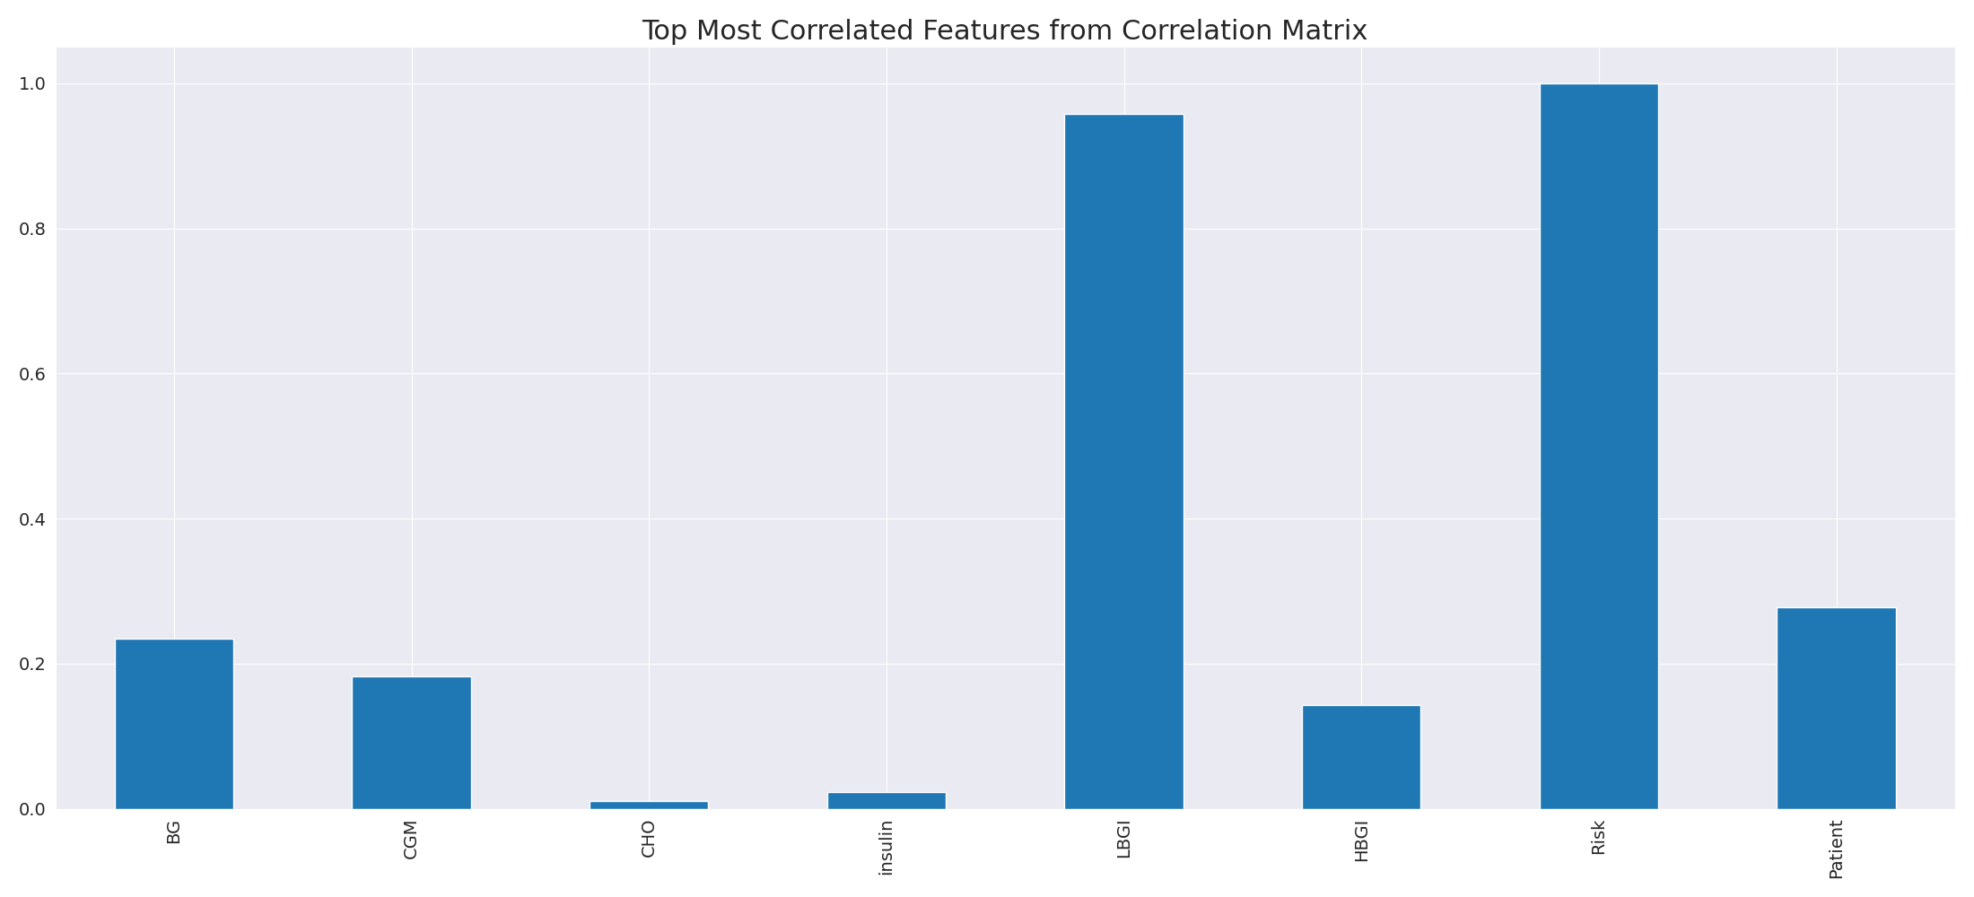

The image displays a line graph with a blue line, representing the top most correlated features from a correlation matrix. The line is long and extends from the left to the right side of the graph. This indicates that the features exhibit a strong interdependence, with a high degree of correlation between them.  
  
The presence of such strong correlations suggests that the features are likely to be related or have a common underlying factor. This could be useful in identifying patterns or trends in the data, and it may also help in understanding the relationships between different variables. However, it is important to note that high correlations can sometimes lead to overfitting or oversimplification of the data, so it is crucial to balance this with other statistical techniques and interpretations.

Missing Numbers Graph Analysis

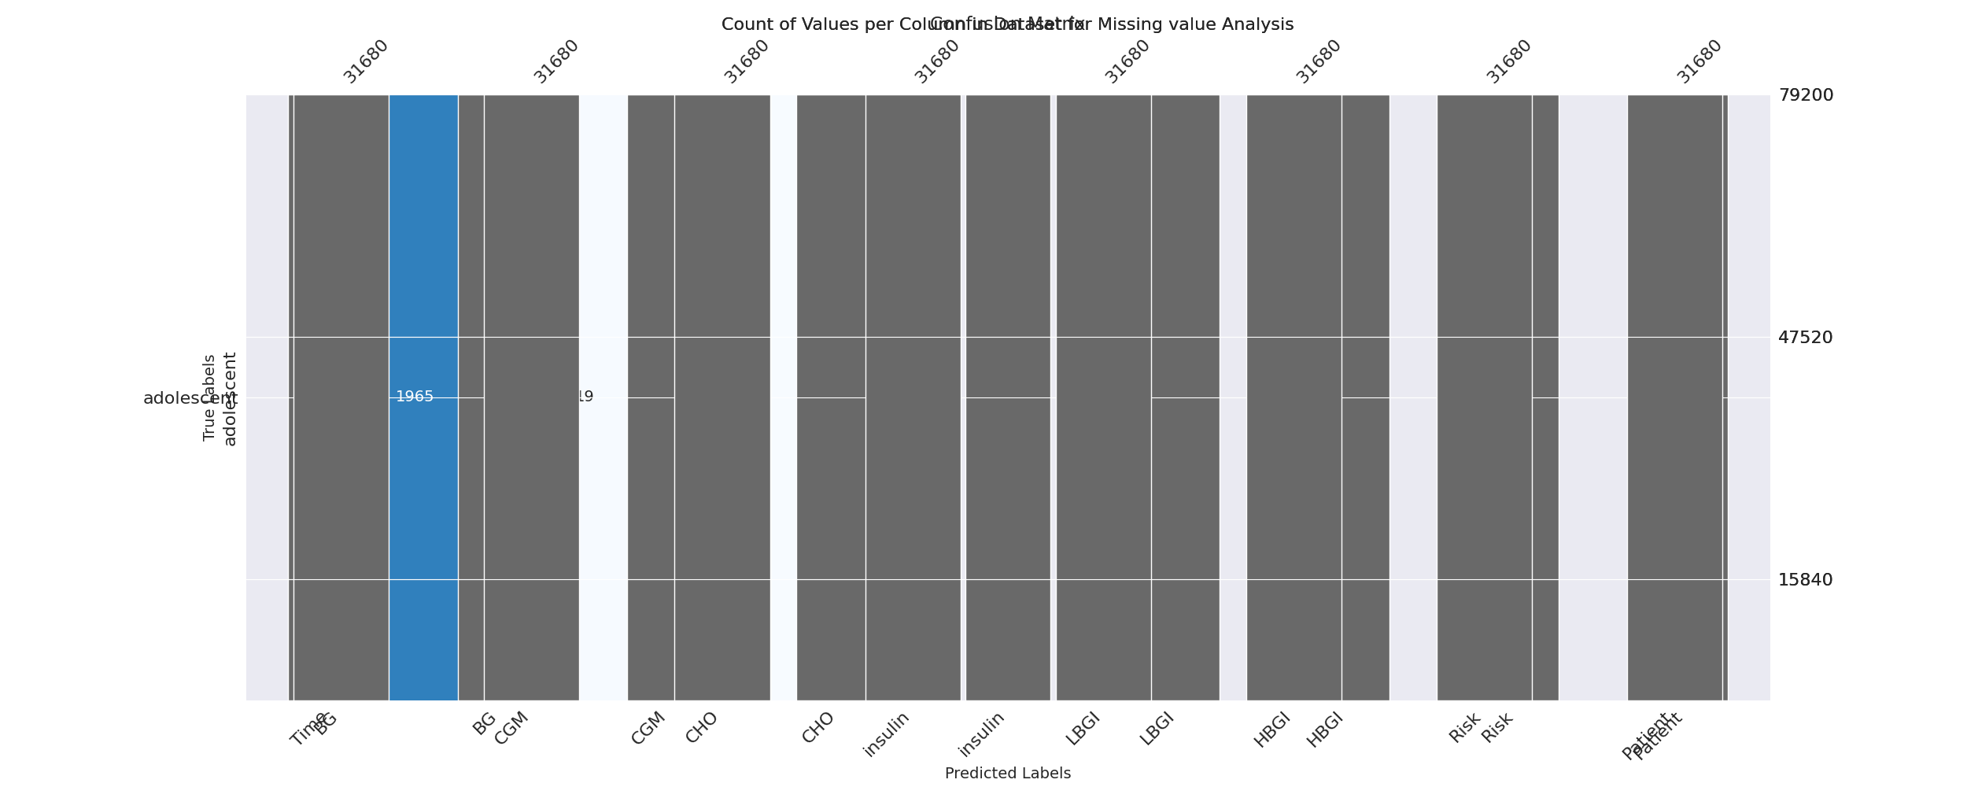

The image displays a graph showing the count of values per column, with some values missing. The graph is labeled "Count of Values per Column," and it is a bar graph with missing values labeled as "Missing." The missing values are distributed across the columns, with some columns having more missing values than others.  
  
The missing values can impact data analysis or modeling in several ways. For instance, if the missing values are not accounted for, the analysis might not be accurate, as the data might not be complete. Additionally, the missing values could be indicative of a problem with the data collection process, such as human error or technical issues.  
  
To address the issue of missing values, exploratory data analysis (EDA) techniques can be employed. These techniques involve visualizing the data to identify patterns, relationships, and anomalies. By examining the distribution of missing values and their impact on the data, analysts can better understand the situation and take appropriate actions to address the issue. For example, they might need to re-collect the data, correct any errors in the data collection process, or use statistical techniques to fill in the missing values.

Heat_Explainer Graph Analysis

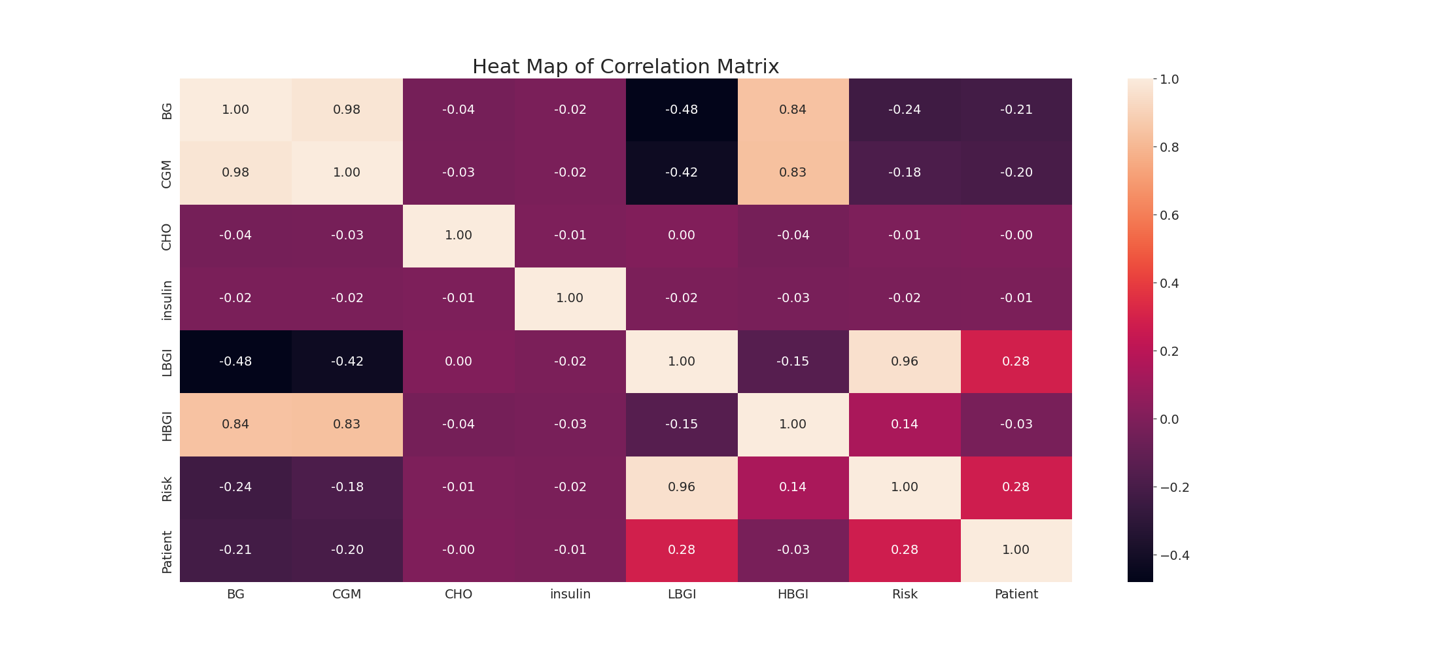

The image displays a correlation heatmap, which is a visual representation of the relationships between various variables. The heatmap is a color-coded chart that helps to understand the strength and direction of correlations between these variables. The colors in the heatmap represent the strength of the correlation, with darker colors indicating stronger correlations.  
  
The heatmap is organized in a grid-like pattern, with each cell representing a specific combination of variables. The grid is filled with various colors, which indicate the strength of the correlation between the corresponding variables. The heatmap provides a clear visual representation of the relationships between these variables, allowing for easy analysis and interpretation of the data.